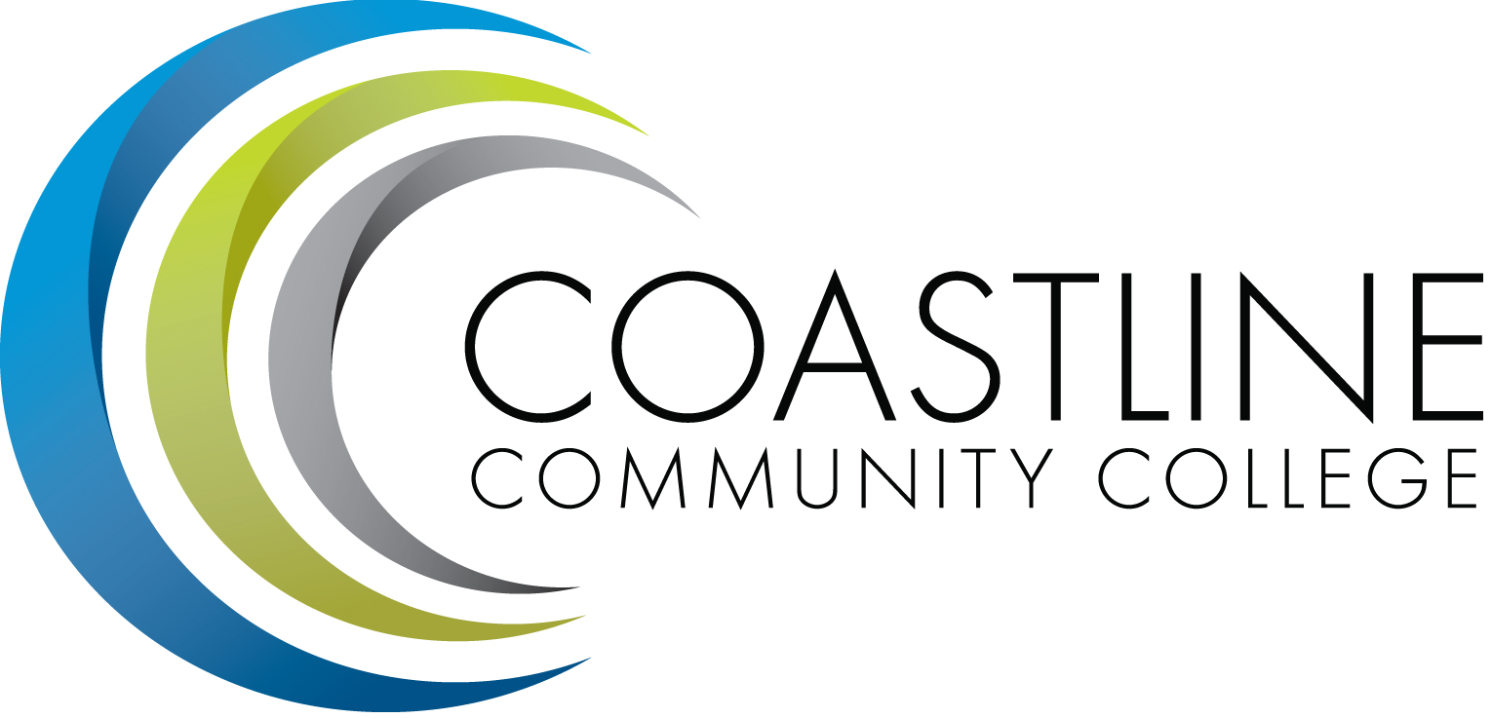

ACADEMIC SENATE
April 3, 2018 12:30 p.m. - 2:30 p.m.
College Center--Fourth Floor Conference Room
AGENDA
College Mission Statement: Coastline Community College steadfastly focuses on providing access and supporting student success and achievement. Inspired by an innovative and student-centered mindset, Coastline delivers flexible courses and services that cultivate and guide diverse student populations across the globe to complete pathways leading to the attainment of associate degrees, certificates, career readiness, and transfer to four-year colleges/universities.

12:30 p.m. 1. CALL TO ORDER: President Stephen Barnes
1.1 Pledge of Allegiance
1.2 Roll Call
1.3 Welcome
1.4 Adopt Agenda
1.5 Approval of Minutes – March 20, 2018**
1.6 Consent Calendar
1.6.1

1.7 Public Comment and Statement: Members of the public can address the Academic Senators on any item that has been described in this notice, before or during consideration of the item. Persons wishing to make comments are allowed three minutes.

2. SPECIAL PRESENTATION
2.1 Noncredit Course and Certificate Development – Dr. Dana Emerson, Michael Scott
2.2 Single CRN for STAR and Regular Admit Students – Dr. Vince Rodriguez
2.3 ASG and Campus Clubs – Kasie Hipp Mirhashemi

3. DISCUSSION AND ACTION
3.1 Guided Pathways Coordinator Job Description
3.2 Faculty Success Center Job Description
3.3 Math Requirements for Option 1 Degree
3.4 Open Elections for Senate Executive Committee and Accept Nominations

4. DISCUSSION ITEMS
4.1 Senate Executive Committee Nominations
4.2 Senate Subcommittee Policies and Procedures
4.3 Faculty Advising
4.4 AP 4020 Program Curriculum and Course Development**
4.5 BP 4020 Program Curriculum and Course Development**
4.6 AP 4230 Grading and Academic Record Symbols**
4.7 BP 4230 Grading and Academic Record Symbols**

5. COLLEGE COMMITTEE REPORTS
5.1 PIEAC – Stephen Barnes
5.2 Budget – Rick Lockwood
5.3 Facilities – Michael Warner
5.4 Technology – Cheryl Chapman
5.5 Professional Development & Leadership – Lisa Lee
5.6 Student Success – Ann Holliday
5.7 Curriculum – Deborah Henry
5.8 Accreditation – Danny Pittaway

6. SENATE SUBCOMMITTEE REPORTS
6.1 Academic Rank – Michael Warner
6.2 Academic Standards – Ann Holliday
6.3 Budget – Ann Holliday
6.4 Communications – David Lee
6.5 Elections – Margaret Lovig
6.6 Faculty Recognition – Ann Holliday
6.7 FSC – Rick Lockwood, Cheryl Chapman
6.8 Policy and Procedures – Deborah Henry
6.9 Social – David Lee

7. ANNOUNCEMENTS: (1-minute limit – please sign list to speak)

2:30 p.m. 8. ADJOURNMENT

*Hand-outs available at meeting.
**Copies have been sent to Senators. Others who would like a copy should contact the Senate office at academicsenate@coastline.edu.

Refreshments
Sandra Basabe & Ted Marcus

Contact the Senate Office ~~ We welcome your input!
Stephen Barnes (714) 241-6156 ~~ Email: academicsenate@coastline.edu
Academic Senate Website: http://www.coastline.edu/academicsenate/
Zoom Link: https://zoom.us/j/619853943

NOTES AND NEWS
Stephen Barnes, Academic Senate President
April 3, 2018
- Classified Senate Spring Fundraiser | Friday, April 20, 2018; 8am – 1pm. Donut and Coffee for sale at College Center. For more information please contact Maria Hernandez Figueroa @ ext. 16427
- Scholarship Ceremony | Thursday, May 3, 2018; 6pm – 9pm. Orange Coast College, Robert Moore Theater. For more information please contact Ashley Lopez @ ext. 16154
- Spring BBQ | May 4, 2018. Garden Grove Campus. More information to be announced.
- Academic Senate Luncheon | Tuesday, May 15, 2018. Garden Grove Campus. More information to be announced.
- Intellectual Disabilities (ID) Program Art and Music Night | Friday, May 18, 2018; 5pm – 7:30pm. Newport Beach Campus in the Art Gallery. Music will be outside, on the first floor. Light refreshments will be served. For more information please contact Lisa Winger @ ext. 17216.
- ASGCCC Installation Dinner | Friday, May 25, 2018. Newport Beach Campus.
- Memorial Day: Monday, May 28, 2018 | All campuses closed.
- 2018 Commencement Ceremony | Friday, June 1, 2018; 4pm. Orange Coast College, Robert Moore Theater.

NEXT MEETING
Date: April 17, 2018
Refreshments: Michael Warner, Kevin Erdkamp

